**Documentation: Interactive Neural Network for Logic Gates**

This documentation provides a step-by-step guide on how to use the Streamlit-based interactive interface for training and evaluating a neural network model on various logic gates.

**Overview**

This interface allows users to:

1. Select a logic gate (XOR, AND, OR, NOR, NAND).
2. Adjust hyperparameters (learning rate, number of hidden units, number of epochs).
3. Train and evaluate the neural network model.
4. Visualize the decision boundary of the trained model.
5. Input custom logical conditions to predict the output using the trained model.

**User Interface**

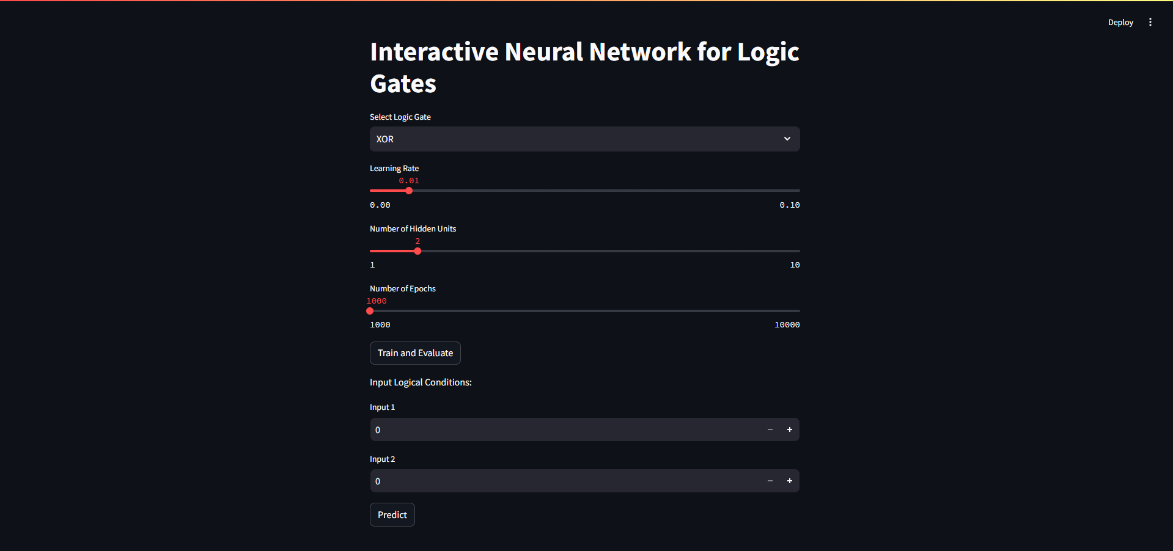

The above screenshot shows the main interface where you can select the logic gate, adjust hyperparameters, train the model, and predict outputs.

**Steps to Use the Interface**

**1. Select Logic Gate**

* **Dropdown Menu**: Use the dropdown menu labeled "Select Logic Gate" to choose the logic gate you want the model to learn. The options are XOR, AND, OR, NOR, and NAND.

**2. Adjust Hyperparameters**

* **Learning Rate Slider**: Adjust the learning rate using the slider labeled "Learning Rate". The range is from 0.001 to 0.1, with a default value of 0.01.
* **Hidden Units Slider**: Adjust the number of hidden units in the hidden layer using the slider labeled "Number of Hidden Units". The range is from 1 to 10, with a default value of 2.
* **Epochs Slider**: Adjust the number of training epochs using the slider labeled "Number of Epochs". The range is from 1000 to 10000, with a default value of 1000.

**3. Train and Evaluate the Model**

* **Train and Evaluate Button**: Click the "Train and Evaluate" button to train the model with the selected logic gate and the specified hyperparameters.
  + **Loss and Accuracy**: After training, the interface will display the final loss and accuracy of the model.
  + **Predicted Outputs**: The predicted outputs for the training dataset will be displayed.
  + **Actual Outputs**: The actual outputs from the dataset will be displayed.
  + **Decision Boundary**: A plot showing the decision boundary of the trained model will be displayed.

**4. Input Logical Conditions for Prediction**

* **Input Logical Conditions Section**: Use the number inputs labeled "Input 1" and "Input 2" to specify the binary inputs for which you want to predict the output.
* **Predict Button**: Click the "Predict" button to get the prediction for the specified inputs using the trained model.
  + **Prediction Result**: The interface will display the predicted output for the given inputs.

**Notes**

* **Training Required for Prediction**: Ensure that you have trained the model by clicking the "Train and Evaluate" button before making any predictions. If the model is not trained, the interface will prompt you to train the model first.

**Example Usage**

1. **Select Logic Gate**: Choose "XOR" from the dropdown menu.
2. **Adjust Hyperparameters**: Set the learning rate to 0.01, hidden units to 2, and epochs to 5000.
3. **Train and Evaluate**: Click the "Train and Evaluate" button.
   * The interface will display the loss, accuracy, predicted outputs, actual outputs, and the decision boundary plot.
4. **Input Logical Conditions**: Set "Input 1" to 1 and "Input 2" to 0.
5. **Predict**: Click the "Predict" button.
   * The interface will display the prediction for the inputs (1, 0), which should be 1 for the XOR gate.

This interactive tool provides an intuitive way to understand how neural networks can learn and predict the behavior of different logic gates. By adjusting the hyperparameters and visualizing the decision boundaries, users can gain insights into the model's learning process and performance.